I'm using git-GUI. I AM CHANGING THINGS LA LA LA LA LA LA LA LA LA AL

Steps on Windows 7:
- Install Git-GUI & msysgit : http://code.google.com/p/msysgit/downloads/list
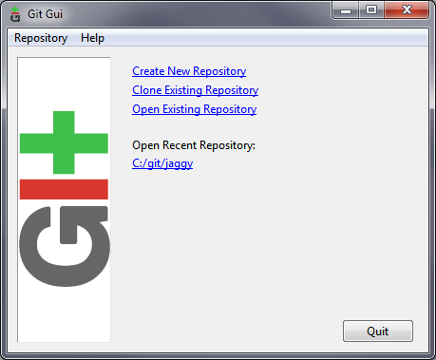
- Click on Git-GUI (default location is either in the start menu under “git” ) and an option screen will display:
- Click “Clone Existing Repository” – this will sync a repository somewhere else with the repository on your local machine.

- Type in the source location from github into the “Source Location on the GitGui. Use c:\git\jagtrack for the target directory: 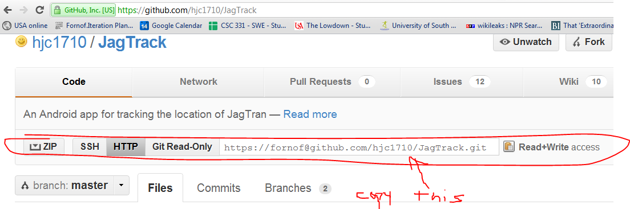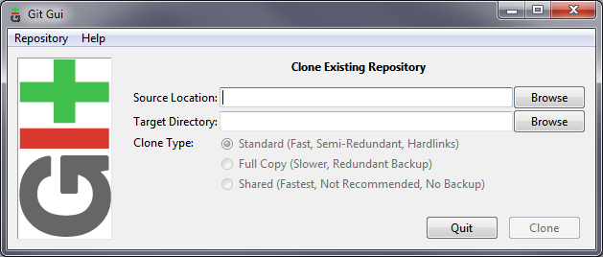

- The program should sync.

- In the Repository menu, click “Explore Working Copy” or browse with windows explorer to your target directory (“c:\git\jagtrack”)

- change a file in the target directory (perhaps add a test.txt somewhere)

- click the following sequence: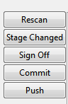

  - Rescan
  - Stage Changed,
  - (sign on - if needed)
  - commit – with an appropriate message in the white space to the right
    - Note: this will change the local copy of the source.
  - Push – default settings are fine
    - Note: Push will sync the local copy with the main branch

